Class Project (Milestone 2):

“The Employee-Project Hours Prototype”

In this project you are asked to refine a C# Windows application that will allow employees and managers to interact with a database called “EmployeeProjects”. This database tracks the hours that employees have on a given project. The database design is shown in the following image.

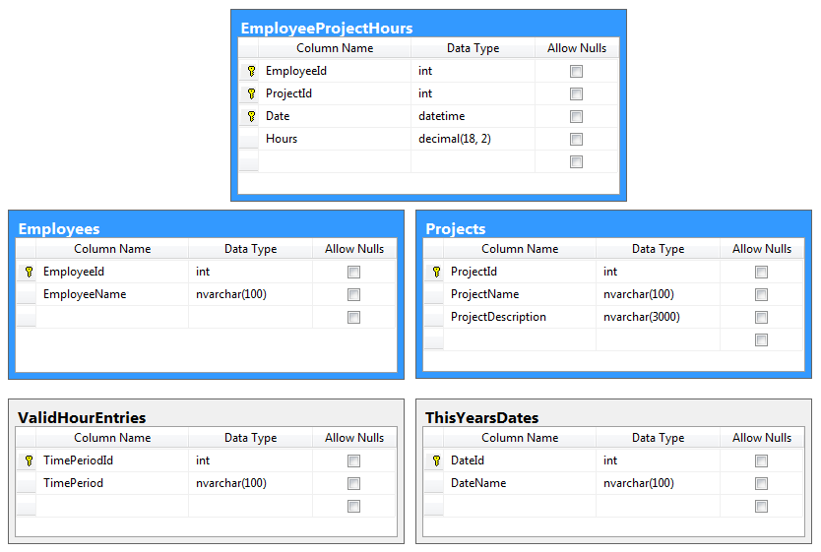

- Re-Create the database and tables, please review and run the following SQL Script "EmployeeProjects Database Script.sql." This file contains updates to the improve the database processing.

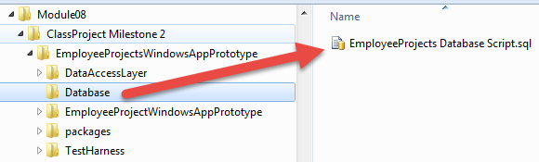
2) Review the instructor provided Interfaces matching the database objects (Both tables and stored procedures!)

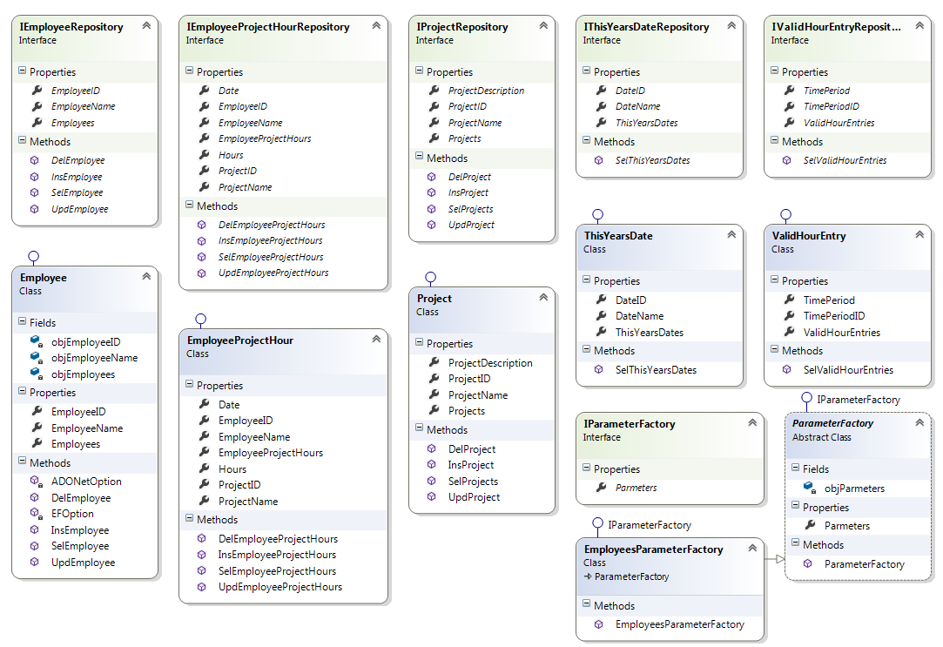

3) Create implementation code for each class using either ADO.NET or the Entity Framework.

4) Create a simple console application to test your work. Here is an example of testing just the one insert command.

